**RESULTS**

1. Below graph Is based on Race ethnicity and frequency

1. Below graph is based on math score and gender

Reading Score and Sex

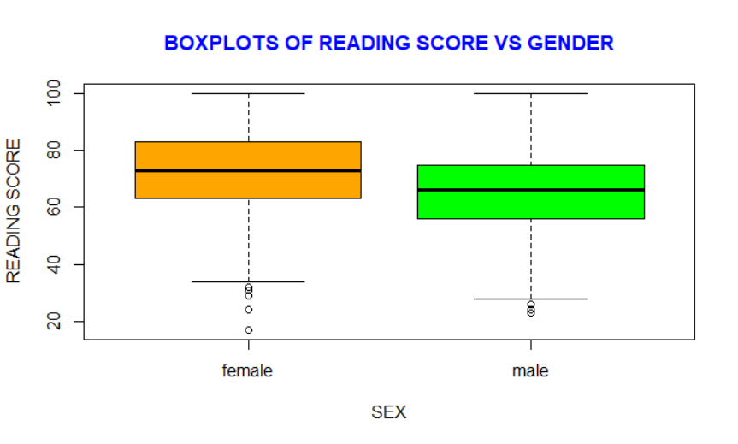

Writing Score and Sex

1. Reading Score and Math Score

4 Graphs between Frequency and Math score Reading Score and Writing

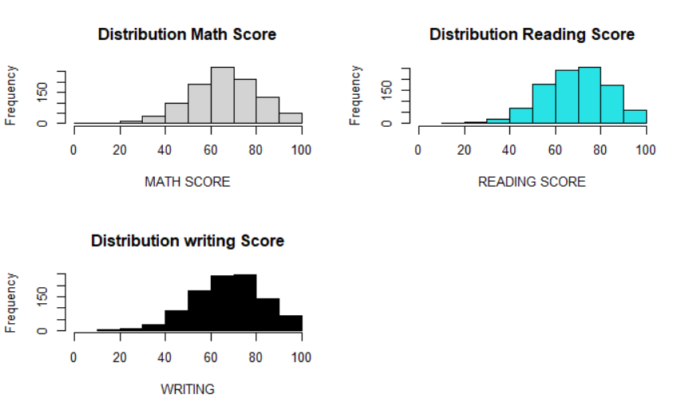

5

